**Name: Sadaf Nahyaan**

**Student # 101100855**

**Part 1: Report**

**Introduction:**

The purpose of this project was to determine how bird nesting settlements have been affected upon the implementation of the Ontario Greenbelt Plan in 2005. The Greenbelt Plan identifies where urbanization should occur to protect the agricultural and ecological features within The Golden Horseshoe region in Ontario, which is one of the fastest growing regions in North America. The Protected region is made up of an Agricultural System and a Natural System, together with a series of settlement areas. Settlement areas within these regions are identified as Towns/Villages and Hamlets and they vary in size, diversity, and intensity. Towns/Villages have the largest concentrations of population, employment, and development within the Protected Countryside. The Greenbelt Plan implements policies regarding the expansion of these urban settlements so that they do not extend into the National Heritage System. Studies have shown how anthropogenic threats are known to kill billions of wildlife annually. One such threat is the predation on urban bird populations by free-roaming domestic cats. Other factors such as collision with man-made structures, vehicles, pollution, and poisoning also cause habitat change that can affect wildlife native to the region. A GIS approach was used to map the nesting sites of various species of bird native to the Greenbelt region and determine whether their populations have increased or decreased after implementation of the Greenbelt Act in 2005.

**Methodology:**

The data needed for this project included: Protected countryside and Urban River Valley designations, Outer boundaries of the Greenbelt, Settlement areas of the Greenbelt taken in 2005 and Wildlife Values Site dataset that represents the consolidation of 13 wildlife data classes collected by the Ministry of Natural Resources and Forestry taken from 1997 to 2020. The First step of this project was to map the Wildlife Values Site dataset of the nesting sites of 34 different species of bird across Ontario. Then using selection tools, the species were narrowed down to only those native to the Greenbelt Protected Countryside. The nesting sites of bird species from 1997 to 2005 were mapped and those after 2005 up to 2020 were also mapped across the Protected Countryside. Nesting sites were mapped under the GCS WGS 1984, a Global Co-ordinate System to minimize distortion.

The next step was to map the settlement areas which were represented as polygons. Settlement sizes are determined by the polygon areas. A graduated symbol theme was used with SHAPE_AREA as the classification field to symbolize the area of the towns and villages. The symbol sizes range from 6 to 14 and have 4 classes made by Equal Interval classification method. Intervals were made ranging from; 0.000015 - 0.000724, 0.000725 - 0.001432, 0.001433 - 0.002140 and 0.002141 - 0.002848, all representing the polygon areas as a unit of the size of the actual settlements. Equal Interval allows for the representation of most of the observations of towns and villages. This is more useful in determining the towns and villages most responsible for the increase or decrease in bird-nesting site observations. The Greenbelt River Valleys and Designation areas were also mapped to see how the species were distributed within these features. All these features were mapped under the GCS North American 1984 co-ordinate system to minimize distortion.

Final step was to create an inset map to give readers an idea of where the Greenbelt Protected Countryside was located on the map of Ontario. The map of Ontario was projected using the NAD 1983 UTM Zone 18N projection and the Greenbelt Designation features were mapped using the original GCS co-ordinate system.

**Results:**

Based on the final map of the project, the species of bird native to the Greenbelt Protected Areas are The Cooper’s Hawk, Osprey and Red-Tailed Hawk. There has been a decrease in number of Birds after 2005 with the Cooper’s Hawk completely gone. One instance of the Red-tailed Hawk was observed after 2005 which is the only species of Red-Tailed hawk to ever inhabit the Protected Area since 1987. Osprey Nesting sites more or less remain the same.

|  |  |  |
| --- | --- | --- |
| Bird Species | Before 2005 | After 2005 |
| Cooper’s Hawk | 9 | 0 |
| Osprey | 4 | 6 |
| Red-Tailed Hawk | 0 | 1 |

The Cooper’s Hawk prefers a habitat of denser forest areas, these hawks tend to prefer easy access to edges, clearing roads and waterways, therefore urbanization due to expansion of towns may be a cause for their disappearance. Looking at the map, most of the Cooper’s Hawk nesting sites are observed within the Oak Ridges Moraine and away from larger towns and villages. This means that settlement areas do affect the spatial distribution of Cooper’s Hawk.

The observation of the only Red-tailed Hawk species is a very recent one made in 2020-03-13. They are known for building new nests every year, so this first observation of the Red-Tailed Hawk nest means that this is the first ever species to inhabit the Greenbelt Area. The nesting site of the Red-Tailed Hawk is observed among the Greenbelt River Valley connection, meaning they tend to make nests along river bodies. They are known to have the ability to nest in varied habitats, however, only one observation of a Red-tailed Hawk is not enough to draw a proper conclusion on their response to urbanization.

The number of Osprey Nesting sites remain mostly the same with a slight increase from 4 observations to 6. They are concentrated mostly within the Oak ridges Moraine with a good number of them located away from the protected countryside before 2005. However, after 2005 they began to build nesting sites towards the river valleys and within the protected regions. They are known to build large nests on utility poles and have caused power outages, therefore it is evident that urbanization does not affect them. The osprey also breeds near freshwater lakes and rivers which explains why some are observed within the Greenbelt River Valley Connections.

**Discussion:**

Based on the results, there is evidence that urbanization through expansion of towns and villages under the Greenbelt Plan of 2005 has significantly affected the populations of Cooper’s Hawk Species that were native to the area. The complete disappearance of Cooper’s Hawk from the Greenbelt area is concerning as they are one of the main predators of perching birds or songbirds. The removal of a predator from an ecosystem can lead to a population explosion in prey species and more competition among prey species for resources. Cooper’s Hawk nesting sites exhibited a pattern of being distributed away from towns with larger polygon areas. Therefore, the size of the town does significantly influence spatial distribution of Cooper’s Hawk nesting sites.

The GIS-approach allows to view the relationships of bird species in response to urban growth however it does not mean that there is causation. There are a variety of other factors that need to be considered such as population of the towns, distances of the nesting sites from certain towns and rivers as well. Extracting census data from the settlement polygon areas can be subject to non-sampling errors leading to unreliability in the results. The results of this project coincide with the main goal of this project which was to determine whether bird nesting settlements have increased or decreased upon the implementation of the Greenbelt Plan in 2005.

**Part 2: User Guide**

**Final Map:**

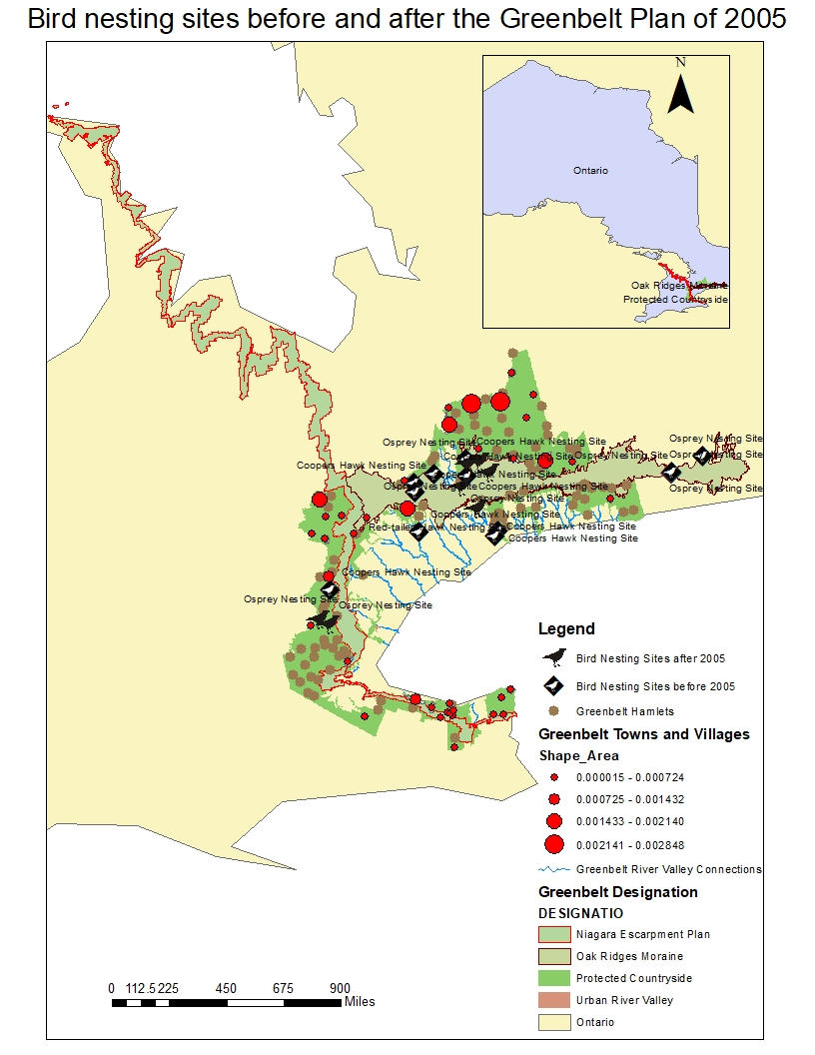

There are two data frames for this project; one for the Greenbelt study area and another for the Inset map. The Study area data frame contains shapefiles of Bird nesting sites before and after 2005, Greenbelt Hamlets, Greenbelt Towns and Villages, River Valley Connection, Greenbelt designation and the Ontario map. The map is zoomed in on the Bird Nesting Site layer to provide the user with the complete view of only the Greenbelt Designation layer containing all the features of interest. The Greenbelt towns and Villages layer, Designation layer and River Valley Connection layers within the Greenbelt Study Area Data frame are mapped under the GCS North American 1984 co-ordinate system and only the Bird nesting site layers are mapped under the GCS WGS 1984 co-ordinate system. Nesting sites before 2005 are given a different label than the nesting sites after 2005 so the user can differentiate between birds of different time frames. All the Bird Species have been labelled so the user can know which type of Bird is observed where. The Towns and Villages have been symbolized with a graduated symbol theme where larger symbols represent larger towns and smaller symbols represent smaller towns. This will allow the user to observe the relationships between Bird Species and Urbanization in the form of settlement size.

The inset map just allows the user to view where the Greenbelt Protected area exactly is on the entire map of Ontario. The inset map data frame contains two layers, one for the map of Ontario which has been projected using the NAD 1983 UTM Zone 18N projection and the Greenbelt Designation layer which was mapped using the GCS North American 1984 co-ordinate system.

**Data Sources:**

1. <https://geohub.lio.gov.on.ca/datasets/wildlife-values-site/data?page=4>
2. <https://data.ontario.ca/dataset/greenbelt-plan-mapping/resource/19e53abf-6642-4e59-af20-e279b2ffa250>.

**References:**

1. Wikipedia contributors. (2020, December 16). Red-tailed hawk. In *Wikipedia, The Free Encyclopedia*. Retrieved 16:44, December 18, 2020, from <https://en.wikipedia.org/w/index.php?title=Red-tailed_hawk&oldid=994553148>
2. Wikipedia contributors. (2020, December 9). Cooper's hawk. In *Wikipedia, The Free Encyclopedia*. Retrieved 16:44, December 18, 2020, from <https://en.wikipedia.org/w/index.php?title=Cooper%27s_hawk&oldid=993152619>
3. Wikipedia contributors. (2020, December 16). Osprey. In *Wikipedia, The Free Encyclopedia*. Retrieved 16:45, December 18, 2020, from <https://en.wikipedia.org/w/index.php?title=Osprey&oldid=994673980>
4. Wikipedia contributors. Greenbelt (Golden Horseshoe). Wikipedia, The Free Encyclopedia. November 29, 2020, 13:51 UTC. Available at: <https://en.wikipedia.org/w/index.php?title=Greenbelt_(Golden_Horseshoe)&oldid=991327575>. Accessed December 18, 2020.